Methodology for the development of the Module 1
(Organization of effective waste collection services)
Sub-activity 1.1 | STEP 1: Identification in advance of the good and bad models related to the focus of the module 1 |  | Days allocated  5
Description
The aim of this sub-activity consists of identification and rapid evaluation of good and bad models/ practices in terms of implementation of the Local Solid Waste Management Plan (LSWMP) as well as other practices and experiences in the region and abroad in terms of other SWM activities that are in the focus of Module 1. The information about good and bad practices will be helpful for the preparation of the following activities (training and coaching) as well as to make local authorities aware for and learning from good and bad examples and why they are functioning or not.

- What good or bad practices consist of
In terms of the organization of the services best practices are considered the successful experiences/ procedures developed so far by the LGUs in the region or abroad.
In focus are:
- LGUs that have been supported during the phase 1 and 2 of dldp programs, for the development of their LSWMP, have benefited investments through grant programs, or are supported with technical assistance to improve current WM services. For example, in focus will be Municipality of Shkodra, Municipality of Lezha, Inter-communal Zadrima, etc;
- LGUs for which dldp has recently performed evaluation in regards of the implementation of their LSWMP such as Commune of Dajc, Guri i Zi and Fushe-Arrez.
- Other LGUs in region or abroad in the country that have achieved success or have failed to implement LSWMP or to develop a cost-effective and qualitative waste collection organization, such as Municipality of Fier, Municipality of Kuçova, etc.

Some of these cases are used as reference or illustration for the preparation of the Manual “Planning on Local Waste Management” (PLWM).

Criteria for the rapid evaluation of the practices includes:
- Overall achievements for the implementation of the LSWMP or of any waste collection scheme, adequate measures taken according to the action plan, investments, qualitative improvements (coverage and level of the service), and cost reduction achievements after intervention (if there are available data, etc);
- Adequate procedures developed for the organization of the working team including leadership aspects, tasks are well clarified and effective utilized, methodologies and standards for the service are defined and well used, effective organization of the technical aspects (collection points, routes, infrastructure, time effectiveness, etc);
- Adequate procedures for the maintenance of the equipments (trucks, containers), the use of the potential professional service providers in the region;
- Bad examples are considered all the failures to fulfill the above points.

- How to proceed
To fulfill the objective of this sub-activity, it needs to gather useful information from potential LGUs mentioned above, and in particular data are collected from dldd reports/ publications (for e.g., plans, dldp Best Practice Experience 2010, etc.) and other publications (Manual on planning of LSWM), LSWMP of Fier, Manual “Standards on local public services in Kuçova”, etc).
These data and information are summarized and analyzed in terms of the identification of the good or bad practices, of the factors, reasons that brought the success or failure to the implement LSWMP/schemes or providing effective and qualitative services. Good and bad practices, findings and lesson learnt will be used and presented for the preparation of the workshop for the module 1 and presented to the participants in the WSh1.

Staff involved
A fulltime expert will be engaged for completing this sub-activity
Products:
- A short presentation of the practices, findings and lesson learnt is prepared for the workshop 1
Expected results:
- Good and bad practices are identified and in-brief assessed.
- The results and findings of these practices are used for the preparation of the models
Sub-activity 1.2 | STEP 2- Organization of the theoretic workshop: | Days allocated  9
Description
The aim of this sub-activity consists of the improvement of the knowledge and capacity building for the LGUs’ experts and local officials in regards of the themes/ models of the Module 1. The development of the Module 1 comprises the development of the theoretical and practical knowledge and practices for three main themes/models specified below. The training materials (theoretic and practical) and their presentation will help LGUs’ experts to understand and utilize adequate steps and instruments for the implementation of LSWMP in terms of organizing the waste services at an effective cost.
- Inputs for the preparation of the WSH materials
Results from the rapid evaluation of LGUs practices (elaborated during the sub-activity 1.1), identification and evaluation of good and bad practices and lesson leant from these cases, LSWMP of the LGUs, the draft-manual on “Plan on Local Waste Management” and training curricula (developed under dldp program) are used as valuable inputs for the preparation of the theoretical and practical materials for this module.
- Theoretical and practical content
In regard of the organization of the theoretical workshop a set of theoretical and practical materials need to be drafted for each theme/model. The content of the materials comprise technical considerations for organizing of an effective waste collection (WC) service, such as:
- Effective management of the working team and administrative personnel;
- Effective technical organization of the WC service (Waste Collection Points (WCP)-network, infrastructure, organization of the collection routes and other considerations);
- Maintenance needs and effective maintenance procedures.

In terms of the documentation and deliveries needed for the Modul 1, in the following are described the main theoretical and practical documents:
Presentations: will provide theoretical knowledge and steps to improve regarding the subject of each model (three models). More specifically, the presentations will cover the issues in regard of the implementation of the LSWMP and organization of the waste collection, such as:
- Management of the working team and of the management personnel: importance and relevance to the cost reduction; job description, tasks and responsibilities; management organizational chart, schedules, rules of operation and their control; how to make use of the team at an effective manner; principles and recommendations, etc;
- Technical aspects of the organization of WC: importance and relevance to the cost reduction; how to implement planned measures and WC schemes; effective design and use of the waste infrastructure (trucks and containers); effective organization of the truck routes; potential obstacles and way to overcome; principles and recommendations according to the subject, etc;
- Maintenance considerations: importance and relevance to the cost reduction; models of good maintenance in the region including private experiences; main problems and ways to overcome them; procedures for evaluation and adequate measures for maintenance and repairs; principles and recommendations; How to establish and approve maintenance procedures.

The presentations will make use of different examples and experiences identified in the region and abroad (during the sub-activity 1.1) and other international examples regarding the subjects. Moreover, the success stories and common problems identified for them are shared and analyzed including causes and consequences of the problem.
Exercises: short exercises are composed as practical tools to illustrate and make use of the knowledge given along presentations. These exercises are prepared for important elements of the organization of the WC, and may comprise specific subjects, like how to design WCP network appropriate , how to design collection routes to different urban areas, defining effective number of working teams, etc.
Templates: Three “Implementation” templates will be prepared in regard of each model of the Module 1; The intention is that these templates are used as guide how to implement action plans and LSWMP requirements or how to improve current practices in terms of the efficiency of the WC. The templates will contain practical steps to be performed according to the subject; things and standards that need to be considered; tips and recommendations for LGUs experts to develop their own models.
Questionnaire templates for reporting: A questionnaire template is prepared for LGUs’ experts, from whom information in regard of existing situation is required. It is supposed that questionnaire template are filled individually by the experts are used as basis for the evaluation of current situation (by using performance indicators for measurements).

- How to proceed
The implementation of this sub-activity comprises the preparation of the training materials (theoretical presentations, models and exercises) and organization of the workshop. From the outset, the technical staff of the project will be engaged in the preparation of the theoretical guide (presentations), which will steer LGUs how to implement LSWMP and its Action-Plan, for technical aspects of the plan and how to shift from planning to practice.
During theoretic workshop it will be explained, clarified and described theoretical models and practical steps, importance and benefits, analyze good and bad models and lesson learnt, and how to proceed and build good models. All the training materials are presented and disseminated, accompanied by the application of some practical exercises for illustration of the theory.
Questionnaire templates are described and distributed to the LGUs’ experts for gathering detailed information. They will be asked to fill the forms and provide useful data for assessing the existing situation, how they are implementing the LSWMP in regards of the models of the module. This information will be used later for the coaching sessions and for measuring current status, effectiveness and quality of local practices on waste collection.
Staff involved:
For the organization of the theoretic workshop will be engaged two technical experts. They will provide training for up to 16 participants (technical experts from LGUs).
Products:
- Theoretic materials (presentations and exercises) for each models for the implementation of the LSWMP in terms of the organization of the services and maintenance, improving waste collection schemes in terms of the reduction of the costs and efficiency,
- Three practical templates/models
- Questionnaire templates for gathering information.

Expected results:
- Theoretic knowledge and practices are shared, disseminated and understood by the participants;
- Local officials and experts are equipped with practical knowledge, steps, templates and procedures how to proceed within their local environment for organization of the services at an effective cost.

Sub-activity 1.3 | STEP 3: Coaching for each LGU (for 6 LGUs) | Days allocated  22
Description
The aim of this activity is that the knowledge and practical steps including models and templates introduced and leant during theoretic workshop will be now exercised by the local experts themselves, within their local environment, under the technical support of the project staff.
Regarding the content/nature of the coaching, the technical support will be focused on three models (already presented) such as the management of human resources (working team and administrative personnel), the organization of the services in terms of technical aspects (infrastructure, organization of routes, etc.) and management of the maintenance of the infrastructure.
The definition of the baseline of the current organization of the WC service will help each LGU to evaluate (compare with examples or similar cases from different LGUs, as well as good and bad examples identified at the earlier phase), and will enable them to identify and understand better problems, gaps, opportunities and things that needs to be changed for each component of WC organization. Under the technical assistance and through following the proposed implementation models and their Action Plan (of their LSWMP), LGUs will develop their own model in accordance with their local conditions, accompanied by a detailed plan of measures and interventions. The intention will be to establish/design a new organization scheme or to foresee the improvement of the existing ones, by intervening/correcting on different elements of management, organization, infrastructure and maintenance aspects and by translating their Action plan into specified and detailed activities. The main goal is to reduce waste collection cost for the same or improved quality of the WC services, such as:
- By making working team more efficient- reduce cost and/or time of operation and quality of service ((i)Adequate job description: tasks and responsibilities for leadership, supervisor and working team; (ii) Effective working team: problems with effective management or less usage of workers; (iii) Operational schedule and their control: Clear rules of operation and improved communication and control of the rules etc);
- By organizing effective waste collection (adequate WCP network, collection frequency, adequate infrastructure and make efficient use of the trucks, etc);
- By avoiding barriers that effect the efficiency of waste collection service;
- By improving level of maintenance and repairs as well as by improving procedures, additional funds; effective opportunities for maintenance, contract professional service provider, etc;

Then, by following their own models they will start to implement their planned measures, interventions and correction measures as well as activities for improving the situation:
- Establish and approve the plan of measures and interventions, schemes, standards, procedures, etc;
- Make correction into WC contracts (when it is possible), or apply corrections at the plan of operation when the service is public.

In terms of the process, this sub-activity consists of the organization of the direct and individual coaching with the LGUs experts to enable the implementation of the LSWMPs and their action plans, as well as to build a cost-effective model for organization of the waste collection services.
The coaching process is divided into three fractions:
- Evaluation of current practices (prior and during the first coaching session), projection and design of the three models (during the first coaching session). This step is provided for each LGU-s and will require preparation and organization of the first coaching, case-by-case according to the needs for each LGU. However, experts from other LGUs are encouraged to attend these coaching sessions. Main actions of this step include:
- Accessing and analyzing of previous activities and evaluate performance;
- Identify problems, deficiencies and opportunities;
- Coach LGUs experts to take decision on best scenario, to design the scheme and start the organization of the services and procedures;
- Give proposals and recommendations and induce LGUs to make corrections.

- Ongoing support, consultation and encouragement will be provided after the first coaching session phase and will be extended till the end of the second training sessions. The second training sessions will be used even for consultation with other interested LGUs experts.
- An ongoing support is foreseen for the LGUs experts. They will be contacted (by phone, emails and invited into the coaching sessions of other LGUs) and helpful instructions or recommendations will be provided case-by-case according to the needs;
- Good practices and progress cases will be checked, encouraged and disseminated further to the other LGUs experts.

- Improvement/corrections, finalization and measuring of the progress are the main actions to be performed during the 2-^{nd} coaching sessions. Each session will be given for two LGUs including one additional session according to the needs. The coupling of LGUs will be based on their geographical location and similar type or size of organization of waste collection. Inter-LGUs opportunities will be explored and used for coupling LGUs in joint coaching sessions. Main actions of this step include:
- Improvement and correction of the procedures, measuring the progress for each models and for each LGUs; (feedbacks will be given by the development of the Module 2 “Controlling and monitoring”;
- Experiences and practices of support are summarized and disseminate to the working group; similar or different examples are discussed and a final set of recommendations are finalized;
- LGUs will be required to officially approve and apply current corrections and improvements procedures, schemes, etc.

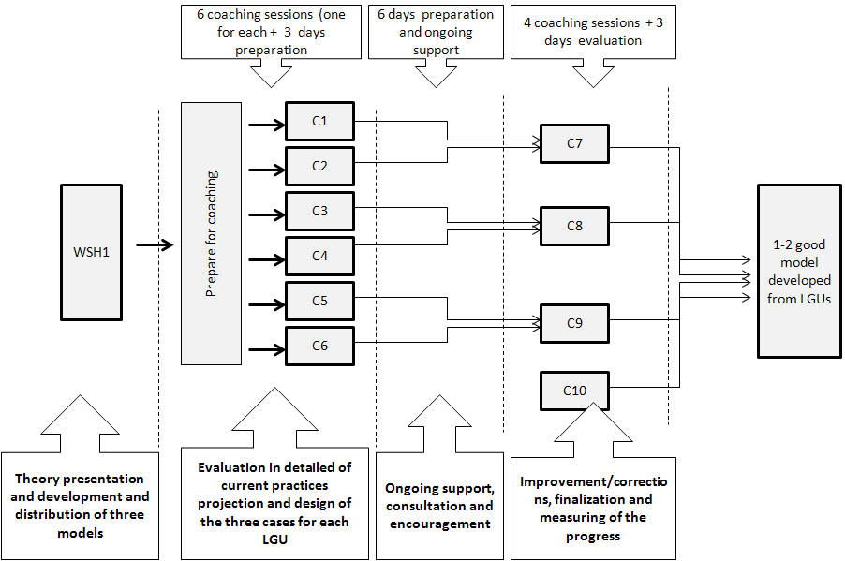
Scheme of the coaching process
Coaching sessions and staff involved:
In total there will be 9 coaching sessions: 1.5 for each LGU + 1 coaching session (additional according to the needs) and 2 days for each LGU for the preparation, evaluation and finalization of the models.
The individual coaching sessions and support for the development of the models will be performed by one technical expert or alternation of them.
Products:
- Individual questionnaire to be completed by the LGUs’ experts and hand over with other supported information or documents (by email) to the project staff, before the coaching session;
- A detailed plan of measures and interventions/corrections for each model: to be drafted by the LGUs experts during coaching 1 and finalized later (not later than a month); Depending on the nature of intervention, it will be required official approval by Public Service Department and/or Mayor new or renewable plan of operation, procedures, reorganization of collection routes, etc; or may need official approval from Municipal Council for e.g. important decision like additional investments, change of the organizational structure of personnel, etc.
- 3- Finalized implementation model: will be completed by LGUs’ experts after the coaching-2 sessions. The model will comprise analysis, plan of measures and interventions/corrections and achieved results (or expected results);
Results:
Local LGUs experts are equipped with practical knowledge and steps to implement their LSWMP and action plan and how to develop good models.
1-2 good implementation models are selected and disseminated to the LGUs experts.

Are developed under Module 2 “Controlling and monitoring”
For example: contracts, regulation, plan of operation, etc

